library ieee;
use ieee.std_logic_1164.all;

entity ram is
generic (bits:integer:=8;
words: integer:=16);
port (clk, rd_nwr : in std_logic;
addr: in integer range 0 to words-1;
data: inout std_logic_vector (bits-1 downto 0));
end ram;

architecture rama of ram is
type vector_array is Array (0 to words-1) of
std_logic_vector (bits-1 downto 0);
signal memory: vector_array;
begin
process (clk,rd_nwr)
begin
if rd_nwr = '1' then data <= memory (addr);
else data <= (others => 'Z');
if clk'event and clk = '1' then
memory (addr) <= data;
end if;
end if;
end process;
end ;

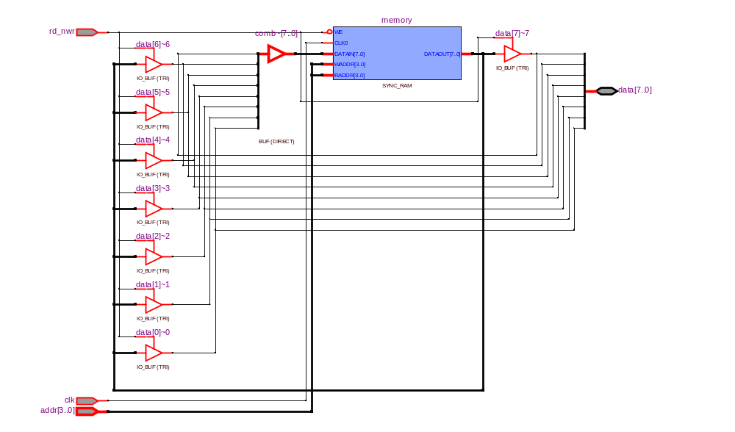

library ieee;
use ieee.std_logic_1164.all;
library lpm;
use lpm.lpm_components.all;
entity ramex is port(
address : in std_logic_vector (7 downto 0);
we, clk : in std_logic;
din : in std_logic_vector (7 downto 0);
dout : out std_logic_vector (7 downto 0));
end;

architecture arc of ramex is
begin
-- lpm_ram_dq : separate input/output data ; lpm_ram_io : common input/output data
-- REGISTERED/UNREGISTERED : DATA+CONTROL INPUTS –
--SYNCHRONIZED (default)/NOT SYNCH to inclock
-- MEMORY FILES : hex, mif - memory initialization file
u1: lpm_ram_dq
generic map (lpm_width => 8,
lpm_widthad => 8,
lpm_outdata => "UNREGISTERED",
lpm_file => "myram.HEX")
port map (data => din,
address => address,
we => we,
inclock => clk,
q => dout);
end;

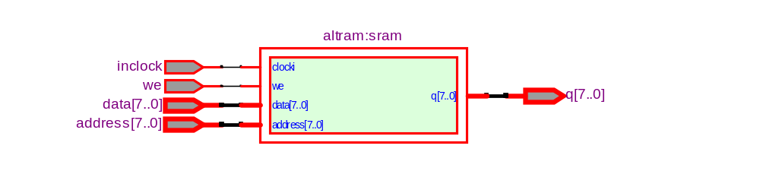

DEPTH = 32; -- The size of data in bits
WIDTH = 8; -- The size of memory in words
ADDRESS_RADIX = HEX; -- The radix for address values
DATA_RADIX = BIN; -- The radix for data values
CONTENT -- start of (address : data pairs)
BEGIN
00 : 00000000; -- memory address : data
01 : 00000001;
02 : 00000010;
03 : 00000011;
04 : 00000100;
05 : 00000101;
06 : 00000110;
07 : 00000111;
08 : 00001000;
09 : 00001001;
0A : 00001010;
0B : 00001011;
0C : 00001100;
END;
% multiple-line comment
multiple-line comment %

-- single-line comment

MIF file example

DEPTH = 32; -- The size of data in bits
WIDTH = 8; -- The size of memory in words
ADDRESS_RADIX = HEX; -- The radix for address values
DATA_RADIX = BIN; -- The radix for data values
CONTENT -- start of (address : data pairs)
BEGIN
00 : 00000000; -- memory address : data
01 : 00000001;
02 : 00000010;
03 : 00000011;
04 : 00000100;
05 : 00000101;
06 : 00000110;
07 : 00000111;
08 : 00001000;
09 : 00001001;
0A : 00001010;
0B : 00001011;
0C : 00001100;
END;

